Experiment No. 3

Title:
Searching Techniques – Linear Search and Binary Search

Aim:
To write a C program to implement and compare Linear Search and Binary Search techniques for finding an element in an array.

Objectives:
- To understand the concept of searching in data structures.
- To learn how Linear Search and Binary Search algorithms work.
- To implement both searching techniques in C language.
- To compare the efficiency and logic of Linear and Binary Search.

Requirements:
- Software: Any C Compiler (e.g., GCC, Turbo C, Code::Blocks).
- Hardware: A computer system with standard configuration.
- Programming Knowledge: Basic knowledge of arrays, loops, and functions in C.

Description:
Searching is a process of finding the location of a given element (key) in a collection of data (like an array).
Two common searching techniques are:

1. Linear Search
- Also called Sequential Search.
- It checks each element of the array one by one until the desired element is found or the list ends.
- Works for both sorted and unsorted arrays.
- Time Complexity: O(n)

2. Binary Search
- Works only on sorted arrays.
- It divides the array into halves repeatedly to find the target element.
- The search space is reduced to half in each step.
- Time Complexity: O(log n)

Algorithm:

Algorithm for Linear Search
- Start
- Input the array elements and the key to be searched.
- Compare the key with each element in the array sequentially.
- If a match is found, return the index.
- If the loop completes without finding the key, return -1.
- Stop

Algorithm for Binary Search
- Start
- Input the sorted array and the key to be searched.
- Set low = 0 and high = size - 1.
- Repeat until low <= high:
  - Find mid = (low + high) / 2.
  - If arr[mid] == key, return mid.
  - Else if arr[mid] < key, set low = mid + 1.
  - Else set high = mid - 1.
- If the key is not found, return -1.
- Stop
Comparison of Linear Search and Binary Search
Parameter | Linear Search | Binary Search
Searching approach | Sequential | Divide and conquer
Data requirement | Sorted or unsorted | Sorted
Search method | Checks elements sequentially | Checks middle element
Reduction of search space | One element at a time | Approximately half at each step
Best-case time | O(1) | O(1)
Average-case time | O(n) | O(log n)
Worst-case time | O(n) | O(log n)
Auxiliary space | O(1) | O(1) for iterative implementation
Implementation | Simple | Comparatively more complex
Suitable for | Small or unsorted data | Large and sorted data

Conclusion
The Linear Search and Binary Search techniques were successfully implemented in C. Linear Search checks each element sequentially and can be used for both sorted and unsorted arrays, whereas Binary Search repeatedly divides a sorted array into two halves to locate the required element. Binary Search is more efficient than Linear Search for large sorted arrays because its time complexity is O(log n) compared to O(n) for Linear Search. Thus, the choice of searching technique depends on the size and organization of the data.

Viva Questions:
- What is searching in data structures?
- What is Linear Search?
- What is the time complexity of Linear Search?
- What is Binary Search?
- What is the main condition required for applying Binary Search?
- What is the time complexity of Binary Search?
- What is the difference between Linear Search and Binary Search?
- Why is Binary Search faster than Linear Search?
- What is the purpose of low, high, and mid variables in Binary Search?
- What does the function return if the searched element is not found, and why is -1 used?

Code for Searching techniques (Binary Search and Linear Search) Using C:

#include <stdio.h>

// ------------------- LINEAR SEARCH FUNCTION -------------------
int linearSearch(int arr[], int size, int key) {
int i;
// Check each element one by one
for (i = 0; i < size; i++) {
if (arr[i] == key)
return i; // Return index if key is found
}
return -1; // Return -1 if not found
}

// ------------------- BINARY SEARCH FUNCTION -------------------
int binarySearch(int arr[], int size, int key) {
int low = 0, high = size - 1;

// Keep dividing the array in half until the element is found or not
while (low <= high) {
int mid = low + (high - low) / 2; // Find the middle index

if (arr[mid] == key)
return mid; // Key found at mid
else if (arr[mid] < key)
low = mid + 1; // Search in right half
else
high = mid - 1; // Search in left half
}
return -1; // Key not found
}

// ------------------- MAIN FUNCTION -------------------
int main() {
int n, i, key, choice;

// Step 1: Ask user for number of elements
printf("Enter the number of elements in the array: ");
scanf("%d", &n);

int arr[n]; // Declare an array of size n

// Step 2: Input elements (for binary search, must be sorted)
printf("Enter %d elements: ", n);
for (i = 0; i < n; i++) {
scanf("%d", &arr[i]);
}

// Step 3: Input the element to search
printf("Enter the element to search: ");
scanf("%d", &key);

// Step 4: Display menu
printf("\n--- SEARCH MENU ---\n");
printf("1. Linear Search\n");
printf("2. Binary Search (Array must be sorted)\n");
printf("Enter your choice (1 or 2): ");
scanf("%d", &choice);

int result = -1; // Variable to store search result
int size = sizeof(arr) / sizeof(arr[0]); // Calculate array size

// Step 5: Perform search based on user choice
switch (choice) {
case 1:
result = linearSearch(arr, size, key);
if (result != -1)
printf("Element found at index %d using Linear Search.\n", result);
else
printf("Element not found using Linear Search.\n");
break;

case 2:
result = binarySearch(arr, size, key);
if (result != -1)
printf("Element found at index %d using Binary Search.\n", result);
else
printf("Element not found using Binary Search.\n");
break;

default:
printf("Invalid choice! Please enter 1 or 2.\n");
}
return 0;
}
Output:
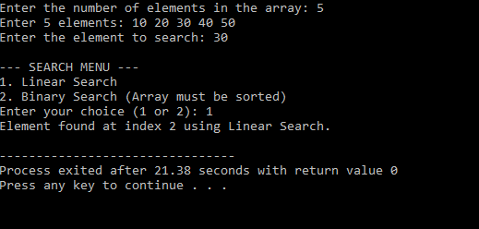
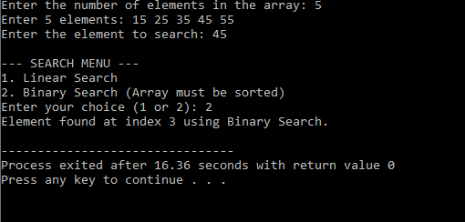

Real-life applications:
- Searching for a student roll number in a student database
- Searching for an employee ID
- Searching for a product ID in an inventory
- Searching for a book accession number in a library
- Searching for a telephone/contact number
- Searching for a customer ID in a database.
Task |  |  |  | Program Variation
Task 1 |  |  |  | Write a C program to implement Linear Search and display the position of the searched element.
Task 2 |  |  |  | Write a C program to implement Binary Search using a sorted array.

